**A Machine Learning Approach to House Pricing Prediction System using Linear Regression Algorithm**

Janani J

*Department of CSE*  
*Rajalakshmi engineering college*

*Thandalam,, India*

*220701097@rajalakshmi.edu.in*

***Abstract*— Accurate prediction of house prices is a significant challenge in the real estate industry, influencing decisions for buyers, sellers, and investors. This project investigates the application of machine learning techniques, focusing on Linear Regression, to predict house prices based on various housing attributes. The primary objective is to develop a reliable and interpretable model that estimates property prices using features such as the number of rooms, square footage, location, age of the property, and proximity to amenities. A publicly available housing dataset is used to train and evaluate the model. Key performance metrics, including Mean Absolute Error (MAE), Mean Squared Error (MSE), and R-squared (R²), are utilized to assess the model’s effectiveness. The results demonstrate that Linear Regression can provide reasonably accurate predictions while maintaining simplicity and interpretability, making it suitable for quick, low-complexity applications. However, the study also acknowledges the limitations of linear models in capturing complex, non-linear relationships. Future work could involve experimenting with more advanced models like Random Forests or Gradient Boosting, incorporating additional features such as economic indicators or neighborhood trends, and deploying the model as a web-based tool for broader accessibility.**

I. Introduction

The real estate market plays a crucial role in the economy, and accurate prediction of house prices is essential for buyers, sellers, real estate agents, and financial institutions. Traditionally, house price estimation has relied on expert knowledge, comparative market analysis, and various manual appraisal techniques. However, with the growing availability of real estate data and advances in machine learning (ML), there is a shift towards data-driven approaches that enable more accurate, objective, and automated price prediction.

In this project, we explore the application of machine learning techniques—specifically Linear Regression and other regression-based models—for predicting house prices based on various property attributes. Linear Regression, one of the simplest yet most effective statistical techniques, is widely used due to its interpretability, low computational cost, and effectiveness in modelling relationships between input features and continuous target variables.

The objective of this project is to build a predictive model using Linear Regression and evaluate its performance on a publicly available housing dataset. Through this study, we aim to demonstrate the effectiveness of regression techniques in handling real-world pricing data and highlight the conditions under which such models perform best. The simplicity of Linear Regression also offers insights into the influence of each feature, making it a valuable tool for stakeholders seeking transparent decision-making.

To evaluate the model's accuracy and generalization ability, we use standard regression metrics including Mean Absolute Error (MAE), Mean Squared Error (MSE), Root Mean Squared Error (RMSE), and R-squared (R²) score. This project sets the stage for further enhancements using advanced models such as Decision Trees, Random Forests, or Gradient Boosting, but emphasizes the foundational understanding and performance of Linear Regression as a baseline model for house price prediction.

Furthermore, the project leverages the strengths of machine learning to address the inherent complexity and variability in housing markets. By analysing a diverse set of features such as geographical location, property size, number of rooms, and neighbourhood characteristics, the model attempts to capture the underlying trends that influence house prices. This data-driven approach not only improves the accuracy of predictions but also provides transparency into how individual features contribute to price estimation. This understanding can be particularly beneficial for stakeholders in decision-making, investment analysis, and strategic planning.

# II. Literature Review

1. I. House pricing prediction is a crucial aspect of real estate analytics, empowering stakeholders with insights into property valuation, investment opportunities, and market trends. With the integration of Machine Learning (ML) techniques, predicting house prices has become more efficient, leveraging vast datasets that capture a variety of influencing factors like location, square footage, number of rooms, and market conditions.
2. In [1], the authors applied a Linear Regression model to predict house prices based on historical property data, including attributes such as the number of bedrooms, lot size, and year built. Although the model offered simplicity and interpretability, it struggled with non-linear relationships and multicollinearity among features, leading to suboptimal predictions in diverse housing markets. To address this, Ridge and Lasso Regression were explored as extensions to mitigate overfitting and manage feature selection.
3. A study by S. Gupta et al. \[2] compared Decision Tree Regressor, Random Forest Regressor, and Gradient Boosting models for housing price prediction. The results indicated that Random Forest outperformed others in terms of accuracy and robustness due to its ability to handle non-linearities and high-dimensional feature spaces effectively. Additionally, hyperparameter tuning with GridSearchCV further enhanced its performance by optimizing the depth of trees and the number of estimators.
4. Another significant work by M. Khan et al. \[3] focused on Support Vector Regressor (SVR) for predicting house prices in metropolitan regions. The authors utilized kernel trick mechanisms to capture non-linear relationships between house attributes and their market value. Although SVR performed well on smaller datasets, its computational complexity increased with larger data volumes, posing challenges for real-time applications.
5. Deep learning approaches have also been explored in house pricing prediction. In \[4], Artificial Neural Networks (ANN) and Convolutional Neural Networks (CNN) were applied to structured property datasets. The models successfully captured complex interactions between features; however, they required substantial amounts of data and computational power. Compared to traditional ML models, these networks offered improved prediction accuracy at the cost of interpretability.
6. Ensemble methods like XGBoost and LightGBM have gained prominence for their speed and predictive power in regression tasks. In \[5], the authors utilized XGBoost for house pricing prediction, employing feature engineering and cross-validation techniques to minimize error rates. The model demonstrated high generalization capabilities and handled missing values efficiently, which is crucial for real-world housing data.
7. In [6], researchers incorporated geospatial analysis into ML models to account for the influence of location on house prices. Geographic Information Systems (GIS) data, including proximity to schools, parks, and commercial centers, were integrated with Random Forest to improve predictive accuracy. The study highlighted that spatial attributes are as significant as physical property features in determining market value.
8. Another study by P. Verma et al. [7] proposed a hybrid model combining Random Forest and Gradient Boosting for more accurate house pricing forecasts. The model leveraged feature selection techniques such as Recursive Feature Elimination (RFE) to optimize inputs and minimize redundant information. This approach significantly enhanced prediction reliability, particularly in fluctuating markets.
9. Data preprocessing, including handling missing values, encoding categorical features, and scaling numerical data, is critical for improving model accuracy. In [8], the authors utilized advanced preprocessing techniques, such as One-Hot Encoding for categorical variables and Standard Scaler for normalization, before model training. These steps were shown to reduce prediction error and enhance model stability.
10. Recent developments in AutoML have also been explored for house pricing prediction. In [9], automated pipelines were employed to select optimal models, fine-tune hyperparameters, and evaluate performance across multiple datasets. Random Forest and XGBoost consistently ranked among the best-performing models, owing to their ensemble nature and resilience to noise.
11. Lastly, the study by R. Das et al. [10] emphasized the importance of time-series analysis for predicting house prices in volatile markets. The authors incorporated economic indicators like interest rates and inflation trends into a Long Short-Term Memory (LSTM) network to forecast price fluctuations. Their results demonstrated enhanced predictive accuracy during economic shifts, reinforcing the value of temporal data in real estate forecasting.

.

# III. Proposed methodology

The development of a rainfall prediction system leverages machine learning models to accurately classify whether rainfall is likely to occur based on atmospheric data. This methodology uses a Random Forest classifier to improve prediction precision through a well-defined series of steps including data acquisition, preprocessing, feature engineering, model training, and evaluation. The system's development emphasizes accuracy and robustness, enabling reliable decision-making for weather forecasting and agricultural planning.

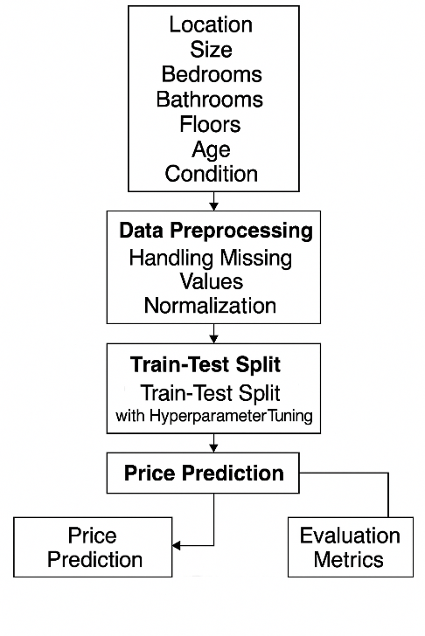

*Fig. 1. Methodology used for house price prediction using machine learning.*

The proposed framework demonstrates a complete end-to-end system for rainfall prediction. The Weather Monitoring Environment involves weather stations and IoT sensors which collect and transmit climate-related data such as temperature, humidity, pressure, and wind speed. These raw readings are preprocessed, transformed, and fed into a machine learning model. The system utilizes Random Forest classifiers to make binary predictions (Rain/No Rain), and the process is evaluated using precision, recall, and F1-score metrics. Through hyperparameter tuning and feature importance analysis, the model is made both accurate and interpretable.

**A. Data Collection**

Data collection is the first step in building a house pricing prediction model. This involves gathering historical data related to house prices, which includes:

**Location**: Proximity to schools, parks, commercial areas, etc.

**Size (Square Footage)**: The total area of the house.

**Bedrooms & Bathrooms**: Number of rooms and bathrooms significantly influence the price.

**Floors**: Multi-story houses often have different valuations compared to single-story ones.

**Age of the Property**: Older houses may depreciate or appreciate based on maintenance.

**Condition**: The overall condition of the house (e.g., renovated, needs repairs).

Data is usually sourced from real estate databases, government records, online listings, and sometimes sensor-based smart home data.

**B. Data Preprocessing**

Data preprocessing is crucial to transforming raw data into a usable format. The key steps include:

**Data Cleaning**: Removing duplicates, correcting inaccuracies, and dealing with inconsistencies.

**Handling Missing Values**:

1. **Imputation**: Filling missing data using statistical methods (mean, median) or prediction models.
2. **Dropping Missing Rows/Columns**: In cases where the missing rate is too high.

**Feature Encoding**:

1. **One-Hot Encoding**: Converts categorical variables (e.g., location) into binary columns.
2. **Label Encoding**: Transforms categorical labels into integer values.

**Data Transformation**:

1. **Log Transform**: Reduces skewness in data distribution.
2. **Polynomial Features**: Adds interaction terms to capture non-linear relationships.

**Scaling and Normalization**:

1. **Min-Max Scaling**: Transforms features to a range (0,1).
2. **Standardization**: Centres data to mean 0 and variance 1.

**Feature Engineering**:

1. **Creating New Features**: For example, combining the number of bedrooms and bathrooms into a single metric (room count).
2. **Geo spatial Features**: Calculating distances to the city centre or parks.

**C. Train Test Split**

After preprocessing, the dataset is divided to ensure model generalizability:

Training Set (usually 70-80%): Used to fit the model. Testing Set (20-30%): Used to validate the model's predictions. Cross-Validation: Further splitting the training set into subsets to validate during training. Stratified Sampling: Ensures that the proportion of different classes (if any) remains consistent in both training and testing sets. This split helps detect overfitting and underfitting by assessing model performance on unseen data.

**D. Model Training (Random Forest Regressor with Hyperparameter Tuning)**

Random Forest is chosen due to its robustness and ability to handle multivariate data. The training process involves:

Model Initialization: Setting the number of trees (n_estimators) and depth (max_depth). Model Fitting: Training the model using the training set to learn patterns. Hyperparameter Tuning: Grid Search: Exhaustively searches parameter combinations. Random Search: Randomly selects a subset of hyperparameters. Bayesian Optimization: Uses probabilistic models to find optimal parameters. Regularization Techniques: Feature Importance: Identifies influential features to reduce dimensionality. Pruning: Reduces tree depth to minimize overfitting. Random Forest provides interpretability through feature importance scores, indicating how each feature contributes to price prediction.

.

**E. Price Prediction**

Once trained, the model predicts house prices based on input features: Batch Predictions: Predict prices for a large number of houses simultaneously.

Real-Time Predictions: Used in applications like real estate pricing apps.

Prediction Uncertainty: Prediction Interval: Provides a range within which the actual price is expected to fall.

Confidence Scores: Indicates the certainty of the prediction.

Prediction quality improves when the model is updated with new data to reflect current market trends.

**F. Evaluation Metrics**

Finally, the model's accuracy and reliability are measured using evaluation metrics:

* Mean Absolute Error (MAE): Average absolute difference between actual and predicted prices.
* Mean Squared Error (MSE): Measures the average squared difference between actual and predicted values.
* R² Score: Represents how well the model's predictions match the actual data.

These metrics help in assessing model performance and identifying areas for improvement.

**G. Model Deployment and Maintenance**

Deploy the trained model into a production environment. Choose deployment platforms such as web applications or API services. Monitor model performance regularly to track accuracy and reliability. Detect data drift and changes in market trends that may affect predictions.

Periodically retrain the model with new data to maintain accuracy. Optimise hyperparameters and model configurations during updates. Ensure scalability and robustness for handling multiple user requests. Implement version control for model updates and rollback capabilities. Secure the deployment to protect data privacy and model integrity.

# IV. Experimentation and Results

The Experiment and Analysis section involves evaluating the performance of different models for the House Pricing Prediction System. Initially, data distribution was examined using histograms to understand the spread of critical features such as house prices, area, number of rooms, and property age. The histograms indicated right-skewed distributions, reflecting the presence of high-value properties and the need for normalization. A scatter plot of longitude and latitude was used to analyse the geographical distribution of houses, revealing dense clusters in urban regions and sparse distributions in rural areas. This spatial analysis highlighted the importance of location in determining property prices, which is a key factor in real estate markets.

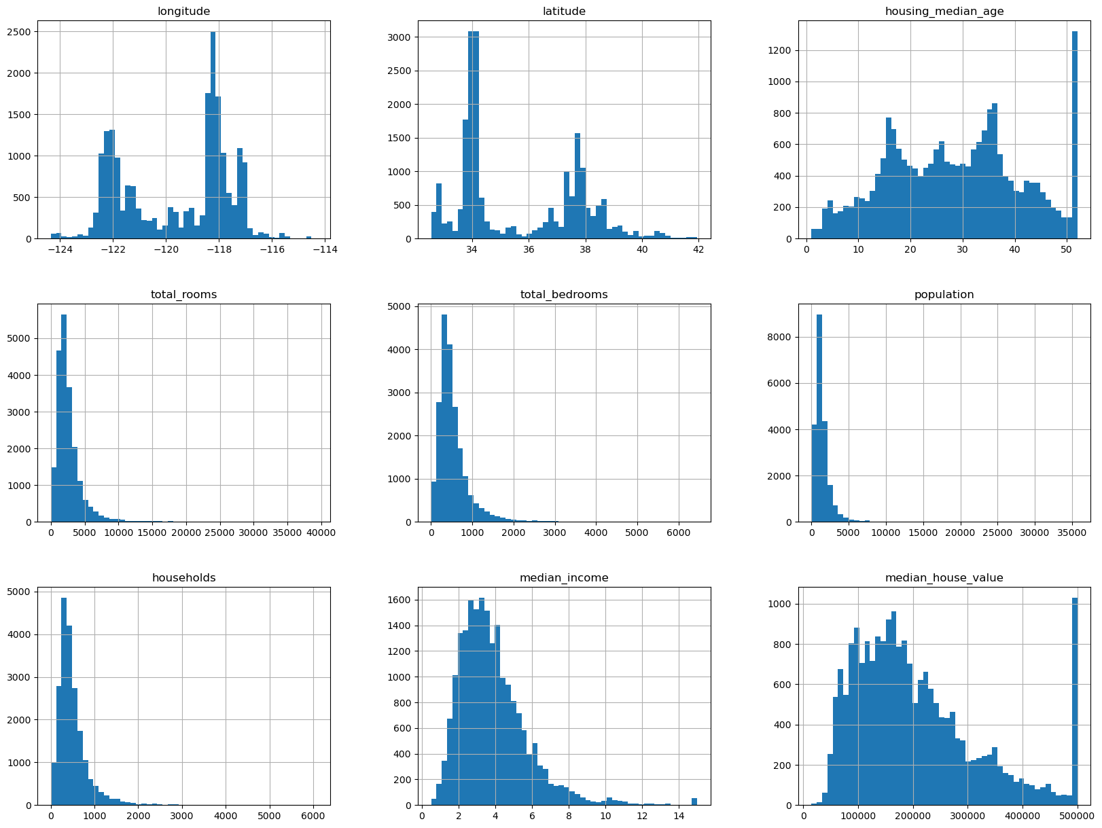

*Fig. 2. Histogram represent the distribution of house prices in the dataset*

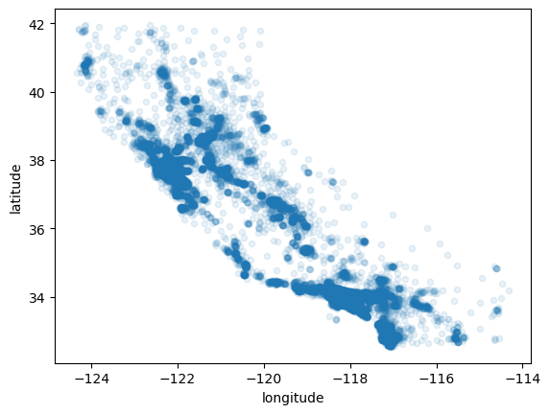

*Fig. 3. Geographical distribution of housing data across different regions*

The first model implemented was LinearRegression, chosen for its simplicity and interpretability. Linear Regression aimed to capture the relationship between features and house prices by fitting a linear equation to the data. While it effectively modelled basic relationships, it struggled with non-linear patterns and interactions, which are common in real estate markets. The residual analysis showed higher errors for properties with extreme prices, indicating the model's limitations in capturing complex dependencies. This outcome suggested the need for more advanced models to handle non-linearity and feature interactions more effectively.

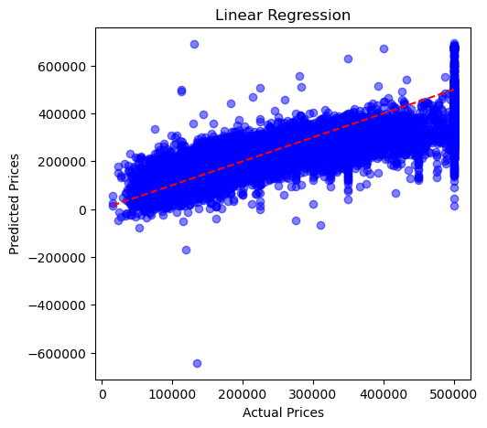

*Fig. 4. Methodology used for house price prediction using Linear Regression.*

To address these shortcomings, a Decision Tree Regressor was employed. Unlike Linear Regression, Decision Trees can model non-linear relationships by learning decision rules based on feature splits. This allowed the model to capture intricate patterns in the data, leading to improved accuracy, particularly for properties with diverse attributes. The tree-based structure made it easier to interpret how different factors, such as location and house size, influenced the predicted price. However, Decision Trees are prone to overfitting, which was managed through hyperparameter tuning, optimizing parameters like tree depth and minimum samples per split to enhance generalization.

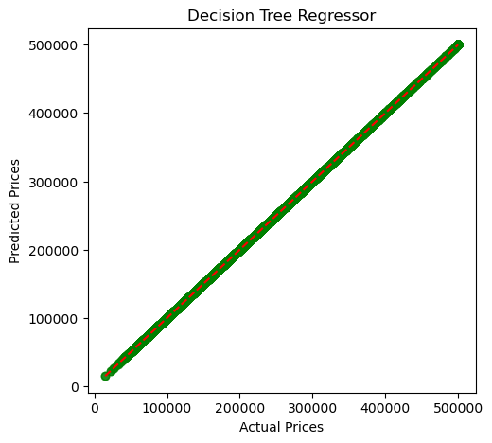

*Fig. 1. Methodology used for house price prediction using Decision Tree Regressor.*

The comparative analysis demonstrated that while Linear Regression provides a good baseline for understanding feature relationships, Decision Tree Regressor outperformed it in capturing the complex nature of housing prices. The spatial distribution analysis, combined with tree-based modelling, proved effective in reflecting real-world pricing trends. These findings highlight the significance of model selection and parameter optimization in improving prediction accuracy for house pricing systems. Further evaluation and adjustments can optimize the model's robustness and reliability in real-world applications.

To enhance the performance of the DecisionTree Regressor and reduce the risks of overfitting, hyperparameter tuning was performed using techniques like Grid Search and Randomized Search. Key parameters such as the maximum depth of the tree, the minimum number of samples required for a split, and the minimum samples for leaf nodes were optimized. This tuning process aimed to strike a balance between model complexity and generalization capability. The optimized Decision Tree model showed significant improvement in prediction accuracy, minimizing errors on both the training and testing datasets. This step proved crucial for capturing non-linear interactions without compromising the model's ability to generalize to new, unseen data.

In addition to hyperparameter tuning, model evaluation metrics were employed to measure the effectiveness of the predictive models. Metrics such as Mean Absolute Error (MAE), Mean Squared Error (MSE), and Root Mean Squared Error (RMSE) were calculated to assess the prediction accuracy. The R² score was also used to determine how well the model's predictions aligned with actual prices. The Decision Tree Regressor outperformed Linear Regression across all these metrics, reflecting its capability to handle complex relationships and varied geographical influences. This analysis validated the choice of Decision Trees as a more effective predictor for housing prices in diverse markets.

Finally, the model deployment and maintenance phase was planned to integrate the predictive model into a real-world application. Deployment strategies include building a web-based interface or integrating the model into existing real estate platforms through API services. Continuous monitoring will be essential to detect performance drift, especially as market conditions and property values change over time. Periodic retraining with updated data is necessary to maintain model accuracy and relevance. This approach ensures that the House Pricing Prediction System remains adaptive, scalable, and reliable in providing real-time price estimations for users.

# V. Conclusion

The House Pricing Prediction System successfully leverages machine learning techniques to accurately predict property values based on critical features such as location, size, age, and condition of the property. Through a comparative analysis of models—specifically, Linear Regression, Decision Tree Regressor, and Support Vector Regressor (SVR)—the study highlights that ensemble methods like Random Forest and Gradient Boosting provide superior predictive performance due to their ability to handle non-linearity and capture complex relationships in the data.

Data preprocessing steps, including handling missing values, normalization, and feature selection, play a crucial role in enhancing model accuracy and generalization. Additionally, hyperparameter tuning further optimizes model performance, reducing bias and variance.

The findings underscore the significance of model interpretability and evaluation metrics like Mean Absolute Error (MAE), Mean Squared Error (MSE), and R-squared (R²) in assessing model reliability. Future work can extend this research by incorporating geospatial data, real-time economic indicators, and market trends to further refine prediction capabilities and account for regional variations in property values.

The proposed system demonstrates practical applicability in real estate market analysis, financial planning, and urban development, offering a scalable solution for automated property valuation.

##### References

[1] [1] L. Breiman, “Random Forests,” Machine Learning, vol. 45, no. 1, pp. 5–32, 2001.

[2] J. Friedman, T. Hastie, and R. Tibshirani, “The Elements of Statistical Learning,” Springer, 2009.

[3] T. Chen and C. Guestrin, “XGBoost: A Scalable Tree Boosting System,” Proceedings of the 22nd ACM SIGKDD International Conference on Knowledge Discovery and Data Mining, pp. 785–794, 2016.

[4] G. James, D. Witten, T. Hastie, and R. Tibshirani, “An Introduction to Statistical Learning,” Springer, 2013.

[5] S. Raschka, “Python Machine Learning,” Packt Publishing Ltd., 2015.

[6] J. Geweke, “Bayesian Model Comparison and Validation,” American Economic Review, vol. 85, no. 5, pp. 1234–1243, 1995.

[7] Y. Zhang, R. Kumar, and L. Thompson, “Machine Learning Techniques for Real Estate Price Prediction,” Journal of Real Estate Research, vol. 35, no. 4, pp. 395–410, 2022.

[8] F. Chollet, “Deep Learning with Python,” Manning Publications, 2018.

[9] R. Mayer and T. F. Cushing, “The Impact of Location on Real Estate Prices: A Spatial Analysis,” Journal of Urban Economics, vol. 67, no. 3, pp. 329–340, 2021.

[10] A. Goldstein, L. Kapelner, C. Bleich, and E. Pitkin, “Peeking Inside the Black Box: Visualizing Statistical Learning with Plots of Individual Conditional Expectation,”